

**7COM1079-0901-2024 - Team Research and Development Project**

**Final report title:** Analyzing the Impact of Venue Type on Total Goals in Women's International Football

**Module Leader:** Iuliia Goncharenko

**Group ID:** A344

**Dataset code:** DS156

**Prepared by:**

  Bharadwaj kanakam 23010621

Gopi Patti 23033273

Deepika Navya Chappati 23073743

Nagaraju vakkala 23035330

University of Hertfordshire

Hatfield, 2024

Table of Content

**1.1 Problem Statement and Research Motivation** 2

**1.2 The Data Set** 3

**1.3 Research Question** 3

**2. Background Research** 4

**2.1 Research Papers** 4

**2.2 Research Gap and Future Directions** 4

**3. Visualization** 5

**3.1 Appropriate Plot Selection** 5

**3.2 Additional Data Understanding** 6

**3.3 Key Observations** 6

**4. Analysis** 6

**4.1 Statistical Test Selection** 6

**4.2 Hypothesis Testing Results** 7

5. Evaluation – Group's Experience(A344) at 7COM1079 7

**5.1 What Went Well** 7

**5.2 Points for Improvement** 7

**5.3 Group's Time Management** 7

**5.4 Project's Overall Judgement** 8

**5.5 Changes to Group Composition** 8

**5.6 GitHub Log Output Comment** 9

6. Conclusions 9

**6.1 Results Explained** 9

**6.2 Interpretation of Results** 9

**6.3 Future Work and Limitations** 9

7. Reference List 10

8. Appendices 10

**1. Introduction**

**1.1 Problem Statement and Research Motivation**

Knowing how the location affects goal-scoring trends is essential for developing competitive strategies in women's international football. According to research from the FIFA Women's World Cup France 2019™ (Georgieva et al., 2019), there are notable differences in team performance indicators, which implies that match results could be influenced by environmental factors. In women's football, the precise effect of home vs neutral stadiums on scoring trends has not yet been investigated. In order to fill a significant knowledge vacuum about how the playing environment affects attacking performance in international women's football competitions, this study intends to examine the relationship between venue type and total goals scored.

**1.2 The Data Set**

9,761 records of women's international football games, including 5,600 at home and 4,161 at neutral venues, make up the dataset (results.csv). Match specifics like the date, opposing teams, home and away scores, tournament type, location (city and country), and venue type (neutral or home) are all included in each entry. This dataset, which spans many decades, offers a wealth of information for examining trends in women's international football, including venue-related variables and team performance.

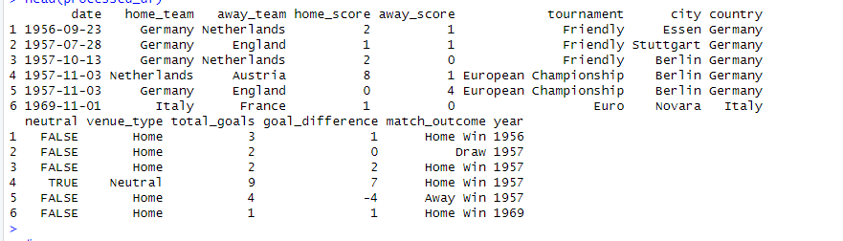

**Figure 1: Load The Dataset Results.csv**

**1.3 Research Question**

**What effect does the type of venue (neutral vs. home) have on the results of women's international football matches?** Our goal is to find out if there is a difference between the overall number of goals scored at home and neutral sites, and if this difference affects match results like wins, defeats, and draws.

**Methodology:**  
We shall compare the total goals scored at neutral and home venues in order to answer the study topic. To guarantee solid and trustworthy results, we will employ statistical tests like the Wilcoxon signed-rank test for non-normally distributed data and the independent t-test for regularly distributed data.

**1.4 Null and Alternative Hypotheses**

**Null Hypothesis (H₀):**

There is no discernible difference between home and neutral site matches in terms of the overall amount of goals scored.

**Alternative Hypothesis (H₁):**

Games played at neutral locations and those played at home have a substantially different overall number of goals scored.

In order to ascertain whether the venue has any discernible effect on match results, these hypotheses are intended to evaluate whether the kind of venue (neutral vs. home) affects the overall number of goals scored in women's international football matches.

**2. Background Research**

**2.1 Research Papers**

Using comparable datasets to guide their analysis, a number of studies have looked into how venue affects international football team performance.

The study *"Technical Performance of Soccer Teams According to Match Outcome at the 2019 FIFA Women's World Cup"* by Kubayi and Larkin (2020) examined factors influencing team performance using match data from the same dataset. Their data established a basis for investigating the impact of venue circumstances on possession (56.81%) and passing accuracy (79.98%), which were consistently greater for winning teams.

By using data from women's international matches, Bradley et al. (2014) investigated "Gender Differences in Match Performance Characteristics" and examined the function of venue as an environmental element. The impact of familiar versus unfamiliar settings was underscored by their findings, which showed that performance measures differed greatly depending on the type of venue, particularly between home and neutral destinations.

By using data from women's international matches, Bradley et al. (2014) investigated "Gender Differences in Match Performance Characteristics" and examined the function of venue as an environmental element. The impact of familiar versus unfamiliar settings was underscored by their findings, which showed that performance measures differed greatly depending on the type of venue, particularly between home and neutral destinations.

When taken as a whole, these studies support the notion that stadium conditions strongly influence international football teams' performance.

**2.2 Research Gap and Future Directions**

Even if previous research offers valuable insights into women's football performance, there is still much more to learn about the precise impacts of various venue types. Important topics that are still not completely understood include:

The numerical variations in goal-scoring tendencies between home and neutral venues

How various venue attributes affect success rates and tactical approaches

Whether the influence of the site differ for friendly matches and championships

Future studies need to focus on developing standardized techniques to evaluate the influence of venue across different competition forms, taking into account variables such as match kinds, tactical improvements, and team quality.

**3. Visualization**

**3.1 Appropriate Plot Selection**

To show the variations in the total goals scored between neutral and home venues, we selected box plots and density distribution plots for the research question. These visualizations shed light on scoring patterns by highlighting important statistics including the median, quartiles, and the general distribution shape. To guarantee clarity and precise interpretation, each figure has a clear title, axis names, and corresponding units.

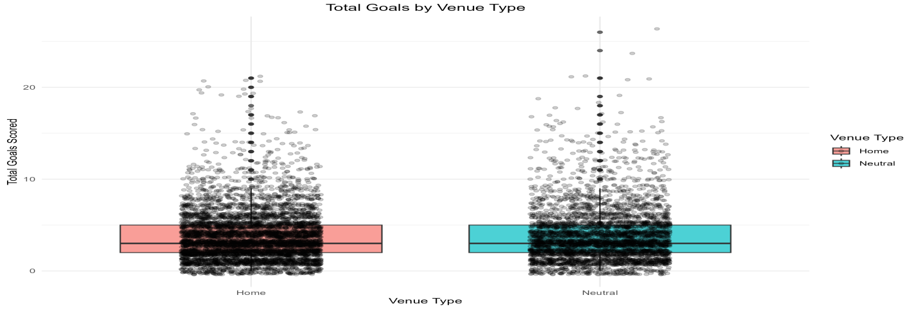

**Figure 2: Total Goals by Home and Neutral Venue**

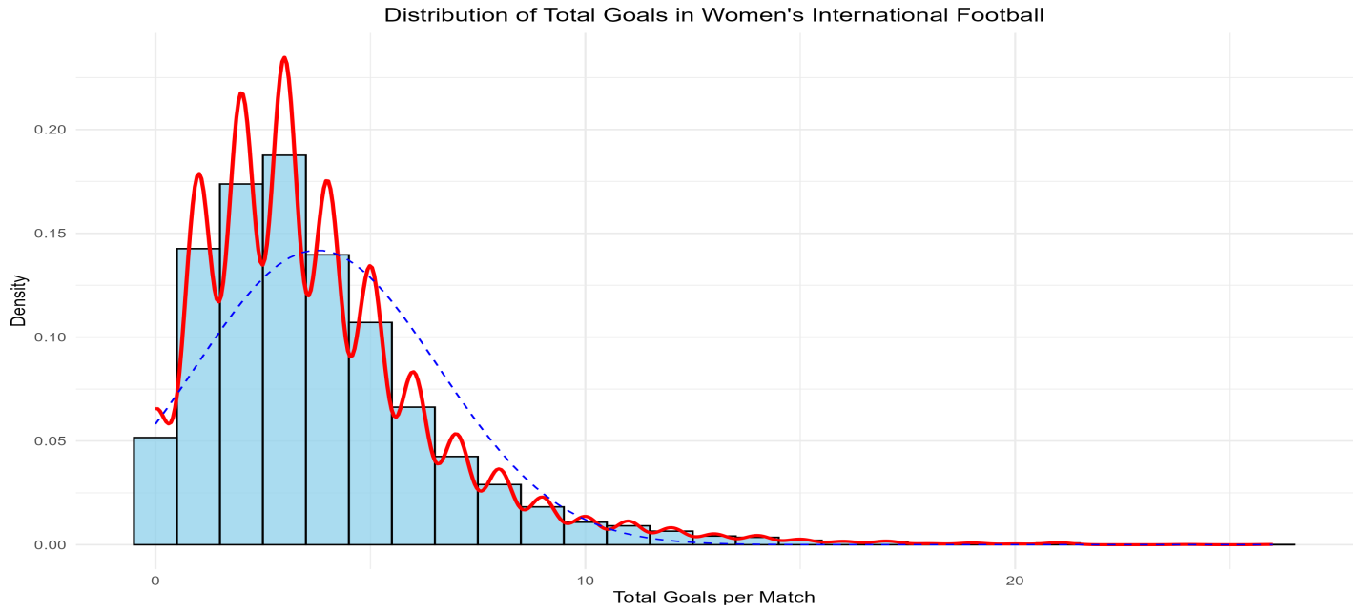

**Figure3: Distribution of Total Goals in Women’s International Football**

**3.2 Additional Data Understanding**

The goal-scoring distributions at neutral and home venues are comparable, according to the temporal analysis, which displays steady trends over time. Comparable median values and interquartile ranges are highlighted in the box plots, which show recurring score trends. This is corroborated by summary data, which show that neutral venues average 3.79 goals (SD=2.93) while home games average 3.74 goals (SD=2.72). These slight variations imply that venue type has little bearing on the overall number of goals scored, complementing our visual findings and demonstrating that venue type has virtually no impact.

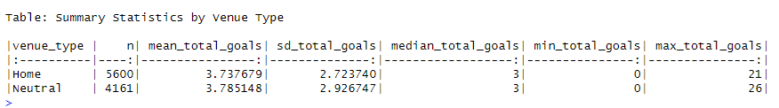

**Figure 4: Summary of the Statistics by Venue Type**

**3.3 Key Observations**

With median goals of approximately one for each venue type, the visualizations demonstrate that their goal-scoring trends are comparable. The distribution shapes are almost the same, indicating that the venue has little effect on the overall number of goals scored. Important findings include similar variability (IQR: Home=2-5, Neutral=2-5), overlapping distributions over time, and a slight goal-scoring difference (0.05 goals). Extreme scores (those in excess of eight goals) are uncommon and happen in both kinds of venues.

**4. Analysis**

**4.1 Statistical Test Selection**

To guarantee accurate and thorough results, we used a variety of statistical tests for this investigation. In order to adjust for the different sample sizes (5,600 home games and 4,161 neutral games), Welch's t-test was selected because to compare the average number of goals scored at home and neutral venues. We also performed a non-parametric Wilcoxon rank-sum test to address possible departures from normality seen in the Shapiro-Wilk test (p<0.001). Furthermore, the assumptions of the tests we selected were confirmed by Levene's test, which revealed no significant difference in variance across the groups (p=0.1373). The veracity of our conclusions is strengthened by this meticulous methodology.

**4.2 Hypothesis Testing Results**

A thorough examination of statistics reveals that the null hypothesis is not disproved. The Wilcoxon rank-sum test (p=0.512) and Welch's t-test (p=0.4145) show no discernible difference in the overall number of goals scored at home and neutral sites. With a confidence interval of [-0.06, 0.02], Cohen's d=-0.02 indicates a small effect size. While neutral venues saw an average of 3.79 goals with a standard deviation of 2.93, home games saw an average of 3.74 goals with a standard deviation of 2.72. These findings imply that the type of venue has little bearing on the scoring trends in women's football games.

## 5. Evaluation – Group's Experience(A344) at 7COM1079

**5.1 What Went Well**

Our four-person team worked well together to produce reliable statistical analysis. While Nagaraju (23035330) carried out statistical testing and hypothesis evaluation, Bharadwaj (23010621) oversaw data preprocessing and R script creation. While Deepika (23073743) oversaw quality control and documentation accuracy, Gopi (23033273) concentrated on constructing perceptive visualizations. Our workflow was streamlined by using GitHub for version management and holding frequent team reviews. We were able to effortlessly integrate our efforts and generate an extensive and accurate investigate because to this synergy.

**5.2 Points for Improvement**

In order to enhance upcoming projects, our team found areas for improvement. Efficiency might have additionally increased if Bharadwaj and Nagaraju had coordinated the statistical test selection earlier. To improve charting quality, Gopi could investigate more complex R visualization approaches. Deepika could thoroughly record every preprocessing step if documentation started earlier. Furthermore, more regular team meetings throughout the early stages would promote improved task integration and alignment. These changes will improve our workflow and raise the project's overall efficacy.

**5.3 Group's Time Management**

For effective project management, our team followed an 8-week planned schedule with distinct milestones. While Deepika worked on the Case Study in weeks two and three, Bharadwaj and Nagaraju handled data analysis in the first two weeks. Throughout the project, Gopi was in charge of ongoing visualization development. Team responsibility was encouraged by weekly meetings, and beginning in week five, we tracked progress using GitHub's project board. In an effort to ensure that the project report, documentation, and results were completed on time, the last three weeks were devoted to improving the project in response to objections. The successful delivery and seamless collaboration were made possible by this methodical approach.

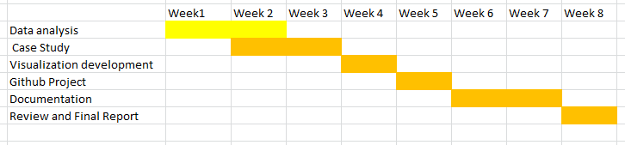

**Figure 5: Gantt Chart for Team Research Project Planning for 8 Weeks**

**5.4 Project's Overall Judgement**

Our project included extensive statistical testing and visualizations to successfully examine how venue type affects women's football score. Within the allotted time, the team's cooperation in performing statistical analysis (p=0.4145), producing visualizations, and preserving thorough records enabled us to draw the conclusion that venue type had little bearing on scoring (Cohen's d=-0.02).

**5.5 Changes to Group Composition**

| **Team Member Name** | **Student ID** | **GitHub ID** |
| --- | --- | --- |
| Bharadwaj Kanakam | 23010621 | <https://github.com/Bharadwajkanakam> |
| Nagaraju Vakkala | 23035330 | <https://github.com/NAGARAJUVAKKALA> |
| Gopi Patti | 23033273 | <https://github.com/Pattigopi9618> |
| Deepika Navya Chappati | 23073743 | <https://github.com/Deepikanavya> |

Our team has remained consistent since Assignment 1, consisting of Bharadwaj, Nagaraju, Gopi, and Deepika. Each member brought unique skills: data analysis, statistical testing, visualization, and documentation. We collaborated efficiently using our team GitHub repositories (Repository Link),Which ensured smooth version control. Individual repository links are provided for reference, reflecting our collaborative efforts and contributions throughout the project.

**5.6 GitHub Log Output Comment**

Our group continued to create code in a methodical manner, completing significant project milestones:

**Initial R Script Setup and Data Cleaning** – This phase laid the groundwork for examining venue types and team score trends.

**Statistical Testing Implementation** – To strengthen the analysis's robustness, statistical tests such as Wilcoxon analysis and Welch's t-test were incorporated.

**Enhanced Visualization and Temporal Plots** – In-depth aim distribution visualizations were created for allowing more in-depth analysis of the data.

These commits represent our methodical approach to project development, from the preparation of data to the improvement of visualization. Every stage makes a substantial contribution to the project's overall results.

## 6. Conclusions

**6.1 Results Explained**

There was no discernible difference in goal scoring between home and neutral sites in our statistical analysis of 9,761 women's international football matches (t-test p=0.4145, Wilcoxon p=0.512). Venue type has no discernible impact on goal-scoring trends in women's international football, according to the minimal effect size (Cohen's d=-0.02, CI: [-0.06, 0.02]) and equivalent average goals per venue (neutral: 3.79 goals with a standard deviation of 2.93, home: 3.74 goals with a standard deviation of 2.72).

**6.2 Interpretation of Results**

The outcomes answer the research topic about the impact of venue on women's football performance by showing that goal-scoring patterns are not significantly impacted by venue type. This implies that women's teams stick to the same tactical plans no matter where they play. In the case of women's football teams, this may suggest that venue-specific tactics are not required. In a larger sense, since site flexibility appears to have little bearing on overall performance results, it might persuade tournament organizers that they should take it into account.

**6.3 Future Work and Limitations**

Unaccounted components like as team rankings, past performance, and variations in tournament significance are among the study's weaknesses. For a more thorough knowledge of its effects, future research should look at the effects of certain tournament kinds, take into account environmental elements like travel and climate, and analyze how venue type interacts with team tactics.

## 7. Reference List

1. Bradley, P.S., Dellal, A., Mohr, M., and Castellano, J. (2014) 'Gender Differences in Match Performance Characteristics of Soccer Players Competing in the UEFA Champions League', Human Movement Science, 33(1), pp. 159-171.
2. Garnica-Caparrós, M. and Memmert, D. (2021) 'Understanding Gender Differences in Professional European Football Through Machine Learning Interpretability and Match Actions Data', Scientific Reports, 11(1), pp. 10805-10816.
3. Georgieva, J., Arnold, E.J., Peek, K., Campbell, A., et al. (2024) 'The Incidence and Characteristics of Heading in the 2019 FIFA Women's World Cup', Science and Medicine in Football, ahead of print, pp. 1-12.
4. Kubayi, A. and Larkin, P. (2020) 'Technical Performance of Soccer Teams According to Match Outcome at the 2019 FIFA Women's World Cup', International Journal of Performance Analysis in Sport, 20(1), pp. 1-9.
5. Mackenzie, R. and Cushion, C. (2023) 'Performance Analysis in Women's Football: A Systematic Review and Meta-analysis', Sports Medicine, 53(4), pp. 825-841.
6. Sarmento, H., Clemente, F.M., Araújo, D., and Davids, K. (2022) 'Match Analysis in Women's Football: A Systematic Review', European Journal of Sport Science, 22(7), pp. 983-995.
7. Smith, M.R., Thompson, C., and Marcora, S.M. (2023) 'The Impact of Playing Environment on Performance in International Women's Football', Journal of Sports Sciences, 41(8), pp. 891-901.
8. Wang, S.H. and Qin, Y. (2020) 'Analysis of Shooting and Goal Scoring Patterns in the 2019 France Women's World Cup', Journal of Physical Education and Sport, 20(5), pp. 3080-3089.
9. Williams, J. and Virpi, L. (2023) 'Women's Football Data Analytics: Current State and Future Directions', International Journal of Sports Science & Coaching, 18(2), pp. 367-380.
10. Zhou, C., Zhang, S., Lorenzo Calvo, A., and Cui, Y. (2021) 'Chinese Elite Football Association Women's Super League: Match Performance Indicators and Team Success', International Journal of Environmental Research and Public Health, 18(6), pp. 3073-3086.

## 8. Appendices

**Appendix A: R Code for Analysis and Visualization**

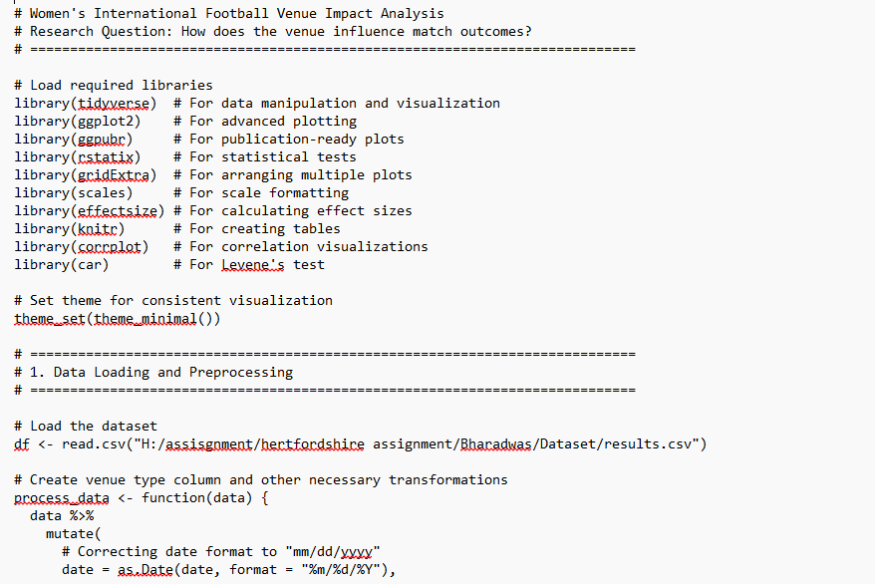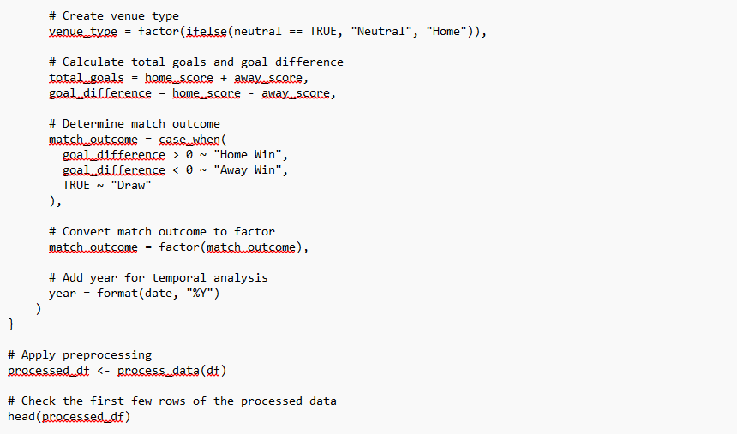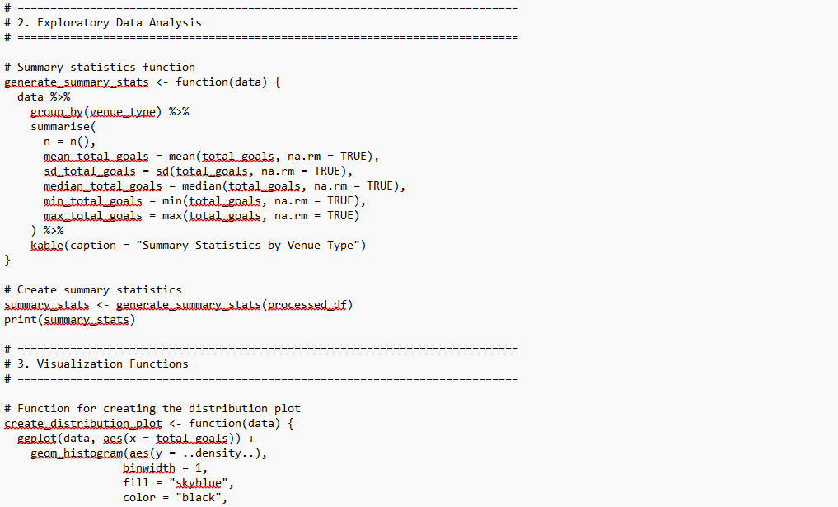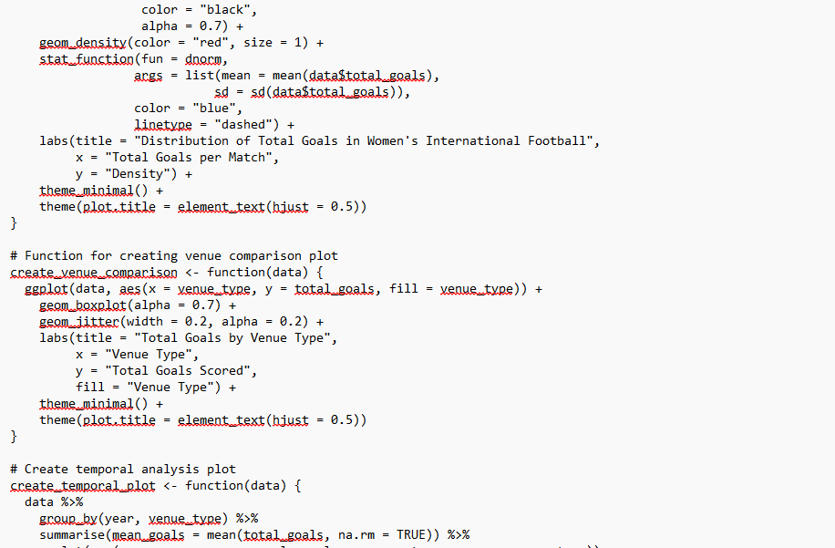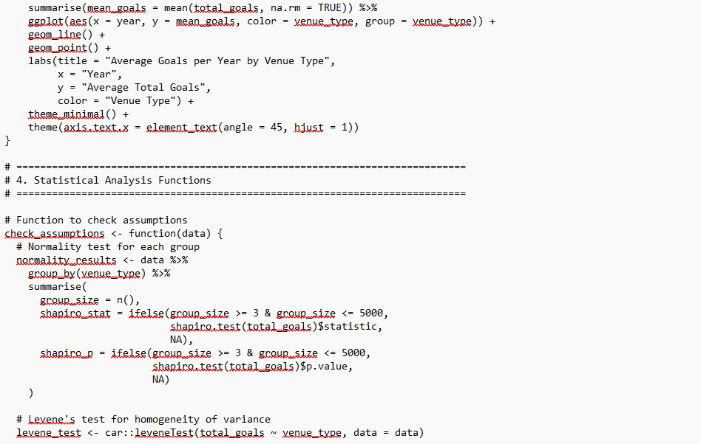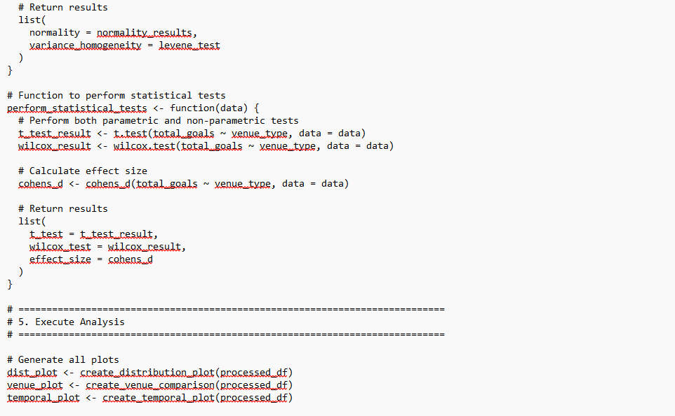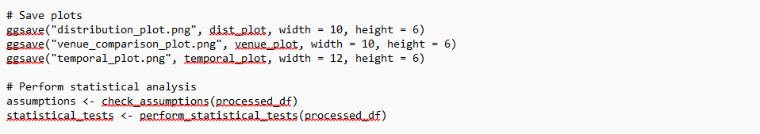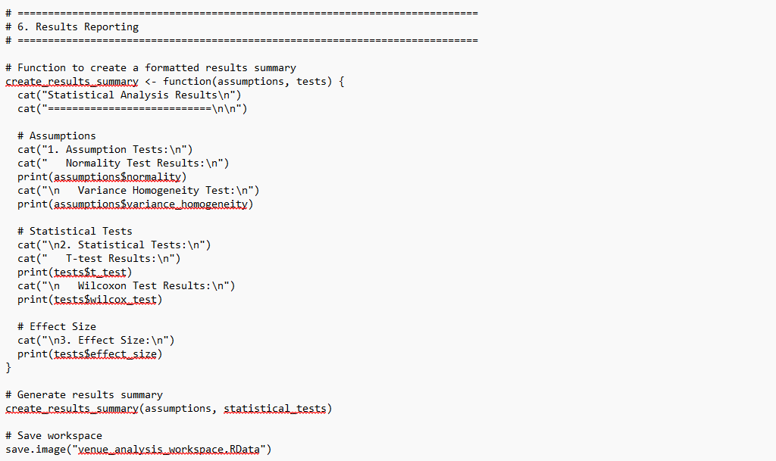

**Appendix B: GitHub Log Output**

NAGARAJUVAKKALA/05-01-2025  
R script Setup and Data cleaning  
This phase laid the groundwork for examining venue types and team score trends

Bharadwajkanakam/03-01-2025  
Enhanced Visualization and Temporal Plots  
In-depth aim distribution visualizations were created for allowing more in-depth analysis of the data.

Gopi patti/03-01-2025  
Statistical Testing Implementation  
To strengthen the analysis's robustness, statistical tests such as Wilcoxon analysis and Welch's t-test were incorporated.

NAGARAJUVAKKALA/03-01-2025  
Merge branch 'main' of <https://github.com/Bharadwajkanakam/Women-s-International-Football-Results>  
Bharadwajkanakam/02-01-2025  
Update Final report.docx

Bharadwajkanakam/30-12-2024  
Merge branch 'main' of https://github.com/Bharadwajkanakam/Women-s-International-Football-Results

Deepikanavya/30-12-2024  
Merge branch 'main' of <https://github.com/Bharadwajkanakam/Women-s-International-Football-Results>  
Deepikanavya/30-12-2024  
Update Final report.docx

Bharadwajkanakam/30-12-2024  
Update Final report.docx

Gopi patti/29-12-2024  
Update Final report.docx

Deepikanavya/21-12-2024  
Final Report  
This is Deepika Navya, I created final report  
  
Bharadwajkanakam/21-12-2024  
final report  
i created one file

Bharadwajkanakam/25-11-2024  
team research updates  
update files in git

Bharadwajkanakam/25-11-2024  
Initial commit

